Developer Guide

jWebSocket
Monitoring resources of computers
Orlando Miranda Gómez
Version 1.0

Version Control
Date | Version | Description | Author
16/05/12 | 1.0 | Creation of document. | Orlando Miranda Gómez
08/06/12 | 1.0 | Modifying the document | Orlando Miranda Gómez

- Overview
The monitoring demo allows users to set up a stable and continuous monitoring of the resources of a computer in real time. You can view the status of resources from a computer or from a cell phone, just having a web browser that supports WebSocket protocol or a flash plug-in for a fallback mechanism, which provides high speed and real-time work. The solution was developed based on the jWebSocket framework.
- Infrastructure, Model, Approach
The Monitoring Application Demo implements the layered architecture, allowing to separate business logic from the logic of design. The Monitoring architecture is divided into two main layers:
- Browser that represents the Presentation Layer.
- jWebSocket server representing Business Layer.
The application does not have a data layer because it does not use a Database for operation. Furthermore, the development can be carried out at various levels. In case a change is required, this only affects the required level without having to check between codes mixing.
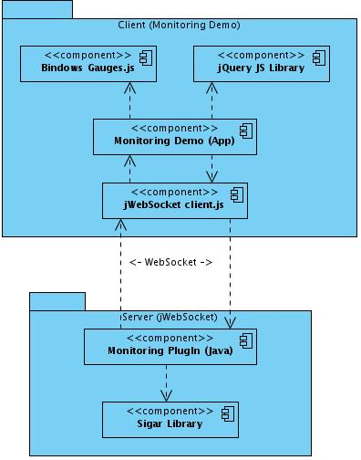
The Monitoring Demo application Utilizes Bindows Gauges, a Java Script library which uses to display XML files called ADF (Application Description Files), for more information follow the next link: http://www.bindows.net/free_gauges/. It runs only on the client side. The application receives the data through the jWebSocket client and consumes features of the jQuery library. The jWebSocket client communicates with the server using the WebSocket protocol and the jWebSocket server contains the monitoring plugin which communicates with the Sigar library that is responsible for obtaining any information of computer resources.
This demo was developed using the TokenPlugin model as it is a lower-level structure in which you do not have many features and where it is easy to process messages, it is best to use since the application will work with higher performance.
- Requistes and prerequistes
The requirements for continuing the development of the Monitoring Demo application are:
- A connecting to the network.
- The native library libsigar-x86-linux.so of Sigar in /usr/lib. For more information see the Administrator Guide in Locations of the Sigar´s libraries
- External Data: use of xml gauges designed for each resource. Each resources has an XML where you set the gauge to obtain the information and operation statements.
Configuring Maven
The jWebSocketMonitoringPlugIn module is configured via pom.xml file, an XML representation of the Maven project within the project folder to configure the dependencies and basic properties of the project.
This file contains various components of Maven, including maven-assembly-plugin, this allows you to bundle all resources of the jWebSocketMonitoringPlugin-1.0.jar file, and here you see how it is used:
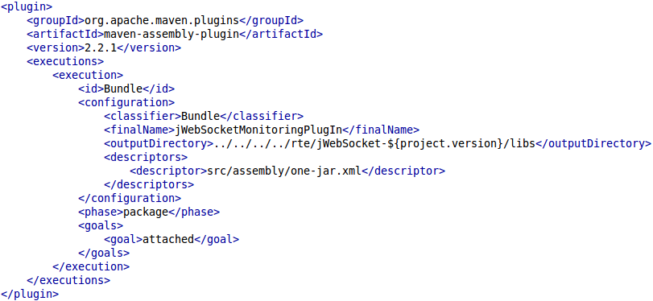
After compiling the project, the file jWebSocketMonitoringPlugIn-1.0.jar is copied into the folder rte/jWebSocket-1.0/libs/.
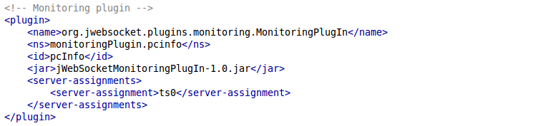
The monitoring plugin settings at run-time can be specified in rte/jWebSocket-1.0/conf/jWebSocket.xml, where you can also configure other plugins. Below is the plugin configuration for jWebSocket:

- Modules, Structure
The Monitoring plugin is implemented in the jWebSocketMonitoringPlugIn module. The table below shows shows the structure of this demo:
Project name: | Monitoring Demo
Location of the sources in the SVN server: | Client | Server
Location of the sources in the SVN server: | https://jwsdev.org:9443/svn/jWebSocket/branches/jWebSocket-1.0/jWebSocketClient/web/demos/jwsMonitoring/ | https://jwsdev.org:9443/svn/jWebSocket/branches/jWebSocket-1.0/jWebSocketPlugIns/jWebSocketMonitoringPlugIn/
SVN branch: | jWebSocket-1.0
Maven Dependency: | 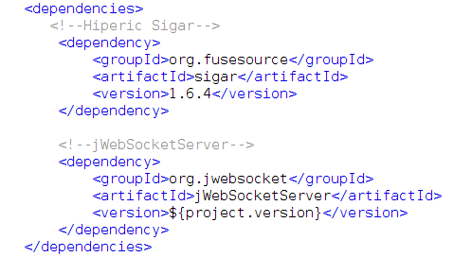
JAR module: | jWebSocketMonitoringPlugIn-1.0.jar
Packet structure: | Space of base name:  org.jwebsocket.plugins.monitoring  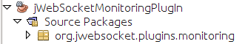
org.jwebsocket.plugins.monitoring:
Contains the mains classes of the module that allows for monitoring management framework jWebSocket.

Client side:
We used the jQuery framework on the jwsMonitoring.htm file. The client libraries and classes for Monitoring Demo application are available in the JavaScript language and are stored at /demos/jwsMonitoring.
Server side:
We used the jWebSocket framework. We provide the MonitorinPlugIn that receives tokens and send data from your computer.
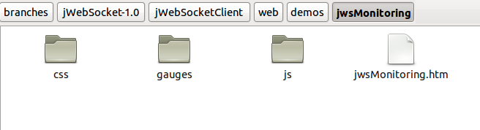
Source code structure
Client:

Description of elements:
css: This directory contains the file that gives style to client components.
js: This directory stores all the files of the libraries used in the client and Java Script files.
jwsMonitoring.htm: This file contains the HTML and JavaScript application.
gauges: This directory contains xml files for the settings of all the clocks that are used with the library bindows_gauges.js. You can examine the source code and find methods or properties of each resources gauge and modify them. See the next image:
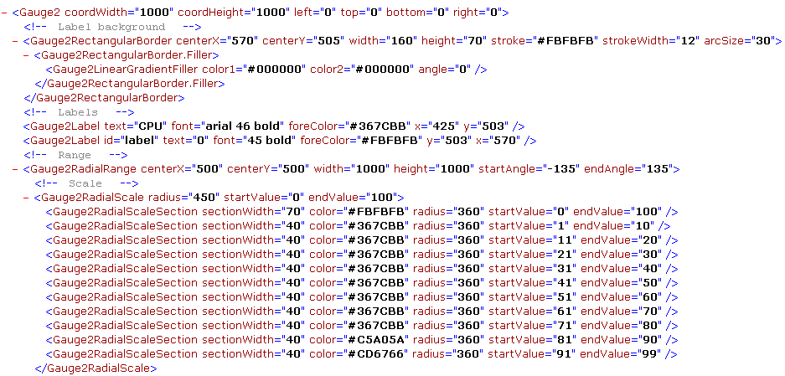

Server:
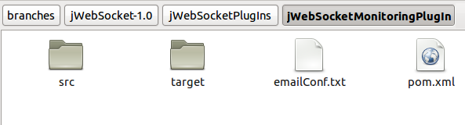
Description of elements:
src: This directory contains all the source code of classes and libraries of the solution.
target: This directory temporarily stores the compiled source code, its content is not included in the version control.
emailConf.text: File to set the necessary parameters for email notification.
pom.xml: Configuration files for jWebSocketServer module that contains information about the project and details of the settings used by Maven to build the project.
- Source Code

Standard of code

To develop the application we used the coding standards of the jWebSocket framework.
Detailed description of the application code
Detailed explanation of the most important customer of monitoring:
monitoring.js
Method | Description
updateGauge() | Get the token "Information" of the server and updates the clocks.
resetGauges() | Sets all values ​​to "0" when the server is stopped.
loadGaugeIntoDiv() | Loads the meters or clocks on the page through a Div.
setValue() | Enter the values ​​to clocks to update dynamically.
setText() | Enter the values ​​in the texts of the clocks.
setEndValue( parseInt( aToken.totalHddSpace) ) | To define the total value on the clock that has the system's hard drive.
toFixed(1) | To obtain values ​​of a place after the comma.
Detailed explanation of the functions of the server and the library used:
MonitoringPlugIn
Type | Method | Description
void | engineStarted (WebSocketEngine aEngine) | Starts the application.
void | engineStopped ( WebSocketEngine aEngine) | Stops the application properly.
void | connectorStarted ( WebSocketConnector aConnector) | Called from inside the jWebSocket server when a user connects to MonitoringPlugin.
void | connectorStopped ( WebSocketConnector aConnector, CloseReason aCloseReason) | Called from inside the jWebSocket server when a user disconnects from MonitoringPlugin.
void | processToken ( PlugInResponse aResponse, WebSocketConnector aConnector, Token aToken) | Processes the received token and adds or deletes a connector to the customer list. The token can be either register or unregister.
void | broadcastInfo() | Creates the token "information" to notify about the memory, hard disk and CPU and sends it to the list of registered clients of the plugin.
java.lang.String | showMemInfo() | Creates a string array which stores all information in the report obtained through Sigar class.
java.lang.String | getInMBytes ( long aValue) | Converts the value of type long memory and returns received by the amount of the type (Kb, Mb or Gb).
java.lang.String | getInMeasure ( long aValue) | Converts hard disk data from long to the type of unit of measure that corresponds to (Kb, Mb and Gb).

Sigar
Type | Method | Description
Mem | getMem() | Obtains the object relating to the RAM.
Swap | getSwap() | Gets the reference to the Swap.
long | getTotal() | Returns the total computer memory.
long | getActualUsed() | Returns the memory used at the current point in time.
long | getUsed() | Returns the value of the Swap currently used.
double | getUsedPercent() | Returns the value of the currently used memory in percent.
double | getFreePercent() | Returns the value of currently free memory in percent.
CpuPerc | getCpuPerc() | Gets the system information from the current CPU usage in percentage format.

- Interfaces
Protocol Used
The Monitoring Demo application is built on the jWebSocket framework, a technology-oriented application development using the WebSocket protocol to provide high levels of speed, security and real-time work; in addition it provides a bidirectional communication channel in full-duplex over a single TCP socket to communicate.
Data format used
This application uses xml for the design of the client; the meters are specified in this format interpreted in bindows_gauges.js library which is part of the Bindows framework. For more information of Bindows follow this link: http://www.bindows.net/.

- Frameworks, libraries and tools
Frameworks:
jWebSocket
Beside being an open source framework it is a technology oriented web application development based on stationary and mobile Java on the server side and JavaScript on the client side. jWebSocket establishes a token model as abstract data through a hierarchical structure and an API provides methods to access its contents. In order to make an abstraction in the handling of different formats, the framework converts the data packets incoming and outgoing tokens.
jWebSocket provides an important set of features and its extensible architecture with plugins to easily add additional features to an independent system. In a cluster components can be used as services, so jWebSocket perfectly compatible with SOA in an environment based on events. These features show the strength and flexibility of the framework for the development of stationary and mobile Web applications, multi-sectoral and compatible with all browsers.
The jWebSocket framework through WebSocket communication provides high levels of speed, scalability, security and work in real time.
jQuery
It is a JavaScript framework. It simplifies the way people interact with HTML documents, manipulate the DOM, handle events and develop animations, achieving great results in less time and space.

Its main feature is that you can change the contents of a Web page without recharging, by manipulating the DOM and AJAX requests. It also allows interactivity and DOM tree modifications, including support for CSS 1-3 and a basic XPath component. It has several utilities to obtain information from the browser, operating with objects, vectors, functions, among others. It is compatible with Mozilla Firefox 2.0 +, Internet Explorer 6 +, Safari 3 +, Opera 10.6 + and Google Chrome 8 +.
The library that is used on the server side is Hyperic Sigar, version 1.6.4. This is a System Information Collector and Reporter, giving our computer data. It is also a multi-platform API that is cross-language library and which provides a command-line tool to access the operating system and hardware level information in Java, Perl and NET. For more information about this library please visit the following links:
http://support.hyperic.com/display/SIGAR/Home http://www.hyperic.com/products/sigar.
The client libraries and classes for Monitoring Extension are available only to the Java language and scripts are stored in the file jwsEventsPlugIn.js. The requirements of external libraries in the client side are:
Library | Description
jWebSocket.js | JWebSocket client library for Java Script, license LPGL.
bindows_gauges.js | Version 1.1 beta3, to display the data dynamically as watches. http://www.bindows.net/worldwide/LatinAmerica.html
jQuery.js | Version 1.5.1, license GPL y MIT. To work with the client-server connection.

- Database and date persistent
MonitoringPlugIn module does not require the use of a database operation.
- Hardware
The MonitoringPlugIn module does not require the use of additional hardware to operate; only the internal computer that are necessary for checking through this application.

